UNITED STATES

SECURITIES AND EXCHANGE COMMISSION
Washington, D.C. 20549

SCHEDULE 14A

Proxy Statement Pursuant to Section 14(a) of the

Securities Exchange Act of 1934

(Amendment No. )

Filed by the Registrant ☒

Filed by a party other than the Registrant ☐

Check the appropriate box:

- Preliminary Proxy Statement

- Confidential, for Use of the Commission Only (as permitted by Rule 14a-6(e)(2))

- Definitive Proxy Statement

- Definitive Additional Materials

- Soliciting Material Pursuant to §240.14a-12

IN8bio, Inc.

(Name of Registrant as Specified In Its Charter)

(Name of Person(s) Filing Proxy Statement, if Other Than The Registrant)

Payment of Filing Fee (Check the appropriate box):

- No fee required.

- Fee paid previously with preliminary materials.

- Fee computed on table in exhibit required by Item 25(b) per Exchange Act Rules 14a-6(i)(1) and 0-11.

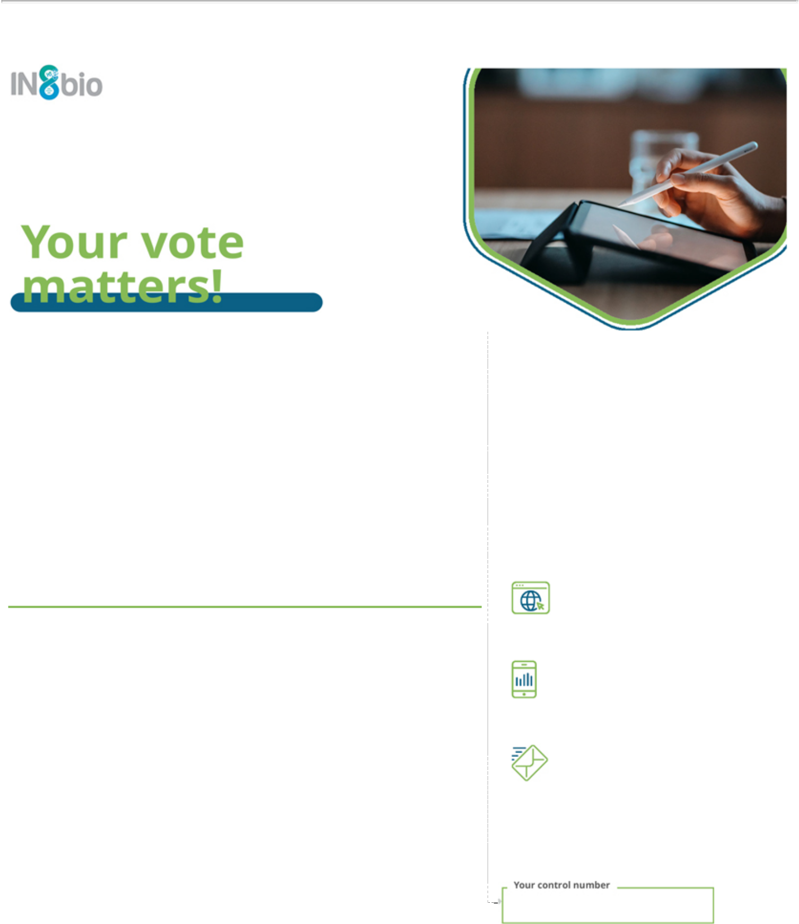
P.O. BOX 8016, CARY, NC 27512-9903

IN8bio, Inc.

Annual Meeting of Stockholders

Thursday, May 8, 2025 9:00 AM, Eastern Time

Annual Meeting to be held live via the internet - please visit www.proxydocs.com/INAB for more details

You must register to attend the meeting online and/or participate at www.proxydocs.com/INAB

For a convenient way to view proxy materials, VOTE, and obtain directions to attend the meeting go to www.proxydocs.com/INAB

To vote your proxy while visiting this site, you will need the 12 digit control number in the box below.

This communication presents only an overview of the more complete proxy materials that are available to you on the Internet. This is not a ballot. You cannot use this notice to vote your shares. We encourage you to access and review all of the important information contained in the proxy materials before voting.

Under United States Securities and Exchange Commission rules, proxy materials do not have to be delivered in paper. Proxy materials can be distributed by making them available on the internet.

If you want to receive a paper or e-mail copy of the proxy material, you must request one. There is no charge to you for requesting a copy. In order to receive a paper package in time for this year’s meeting, you must make this request on or before April 28, 2025.

SEE REVERSE FOR FULL AGENDA

Meeting Materials: Notice of Meeting and Proxy Statement & Annual Report or Form 10-K

Important Notice Regarding the Availability of Proxy Materials for the Stockholders Meeting To Be Held On May 8, 2025 For Stockholders of record as of March 12, 2025

To order paper materials, use one of the following methods.

Internet:

www.investorelections.com/INAB

Call:

1-866-648-8133

Email:

paper@investorelections.com

- If requesting material by e-mail, please send a blank e-mail with the 12 digit control number (located below) in the subject line. No other requests, instructions OR other inquiries should be included with your e-mail requesting material.

Have the 12 digit control number located in the box above available when you access the website and follow the instructions.

Copyright © 2025 BetaNXT, Inc. or its affiliates. All Rights Reserved

IN8bio, Inc. Annual Meeting of Stockholders


THE BOARD OF DIRECTORS RECOMMENDS A VOTE FOR ALL NOMINEES FOR DIRECTOR IN PROPOSAL 1 AND FOR EACH OF PROPOSAL 2 AND PROPOSAL 3

PROPOSAL

- To elect the three Class I directors named in the attached proxy statement, each to serve until our 2028 Annual Meeting of Stockholders.

1.01 Emily Fairbairn

1.02 Jeremy Graff

1.03 Luba Greenwood

- To ratify the selection of CohnReznick LLP as our independent registered public accounting firm for the fiscal year ending December 31, 2025.

- To approve a series of alternate amendments to our Amended and Restated Certificate of Incorporation to effect, at the option of our Board of Directors, a reverse stock split of our common stock at a ratio in the range of 1-for-15 to 1-for-30, inclusive, with such ratio to be determined by our Board of Directors in its sole discretion.

